FOM2 Unit 2 Quiz 1 REVIEW – MATHO QUESTIONS Name ___________________________
Date ____________ Period _____

Find the vertex, state the axis of symmetry, and determine if the function has a max or min.
1. $y={\left(x-3\right)}^{2}+6$ 2. $y=1/2{\left(x+7\right)}^{2}$ 3. $y={\left(x-2\right)}^{2}+5$

3. ${y=\left(x+3\right)}^{2}$ 5. $y=3x^{2}+6x+1$ 6. ${y=-3\left(x+2\right)}^{2}+4$

7. $y=2x^{2}+28x-41$ 8. $y=2{\left(x-3\right)}^{2}+1$

(EXCLUDED ON MATHO PROBLEMS) Graph the given function by finding the vertex and reflecting two other points.
9. $y={-\left(x-5\right)}^{2}-1$ 10. $y={\frac{1}{2}\left(x-6\right)}^{2}+2$.
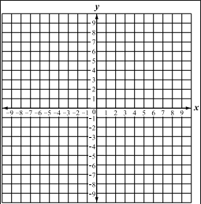

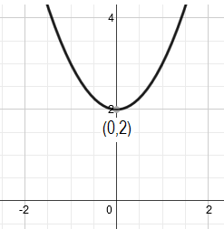
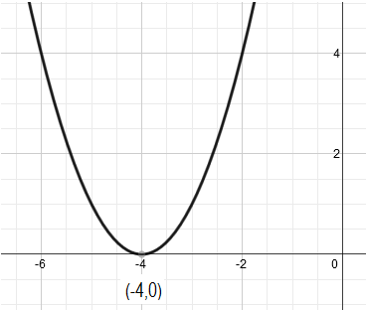
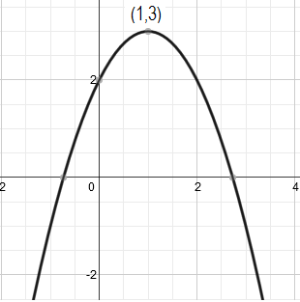
Given the graph, write the equation of the quadratic. Assume that a=1 or -1.
11. 12. 13.

Write the equation in standard form.
14. $y={\left(x+3\right)}^{2}-5$ 15. $y={2\left(x-1\right)}^{2}-2$ 16. $y={-\left(x+4\right)}^{2}+10$

Write the equation in vertex form.
17. $y=-2x^{2}+12x+5$ 18. $y=7x^{2}+28x+12$ 19. $y=3x^{2}-8x+10$

Write the equation for the parabola.
20. Vertex (-2, -1), passes through (0, -5) 21. Vertex (-1, 1), passes through (2, -17)

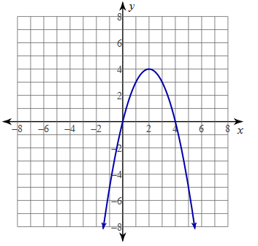
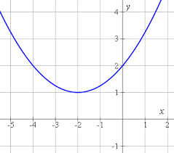
22. 23.

Describe each transformation from the parent function $y=x^{2}$. Then state the Vertex.
24. $y={-(x+3)}^{2}-12$ 25. $y=5{(x-21)}^{2}$ 26. $y=-x^{2}+39$

27. $y=\frac{3}{16}{(x-1)}^{2}-16$ 28. $y={\frac{10}{3}x}^{2}$ 29. $y=2x^{2}-16x+37$

Write a function for each
30. A parabola that has a been stretched vertically by a factor of 8 and moved right 11.
31. A parabola that has been shrunk vertically by a factor of $\frac{1}{3}$, has been reflected over the x-axis and moved left 7.
32. A parabola that has been shifted 15 units left, has a vertical stretch factor of 6, and has been shifted up 2.

